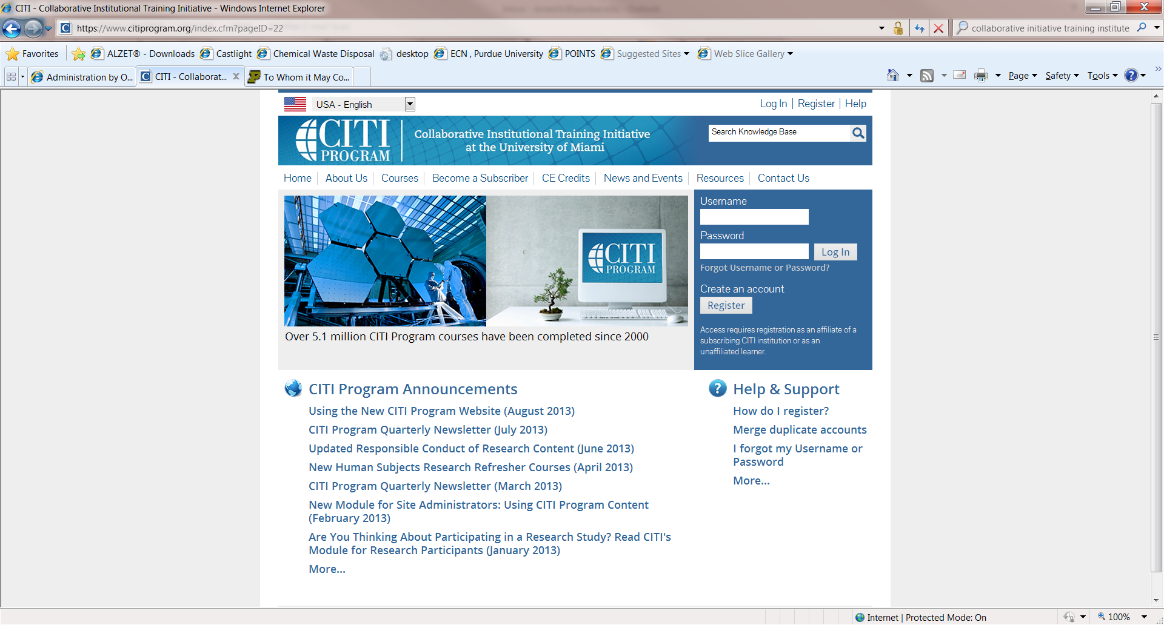

Click create an account

Register

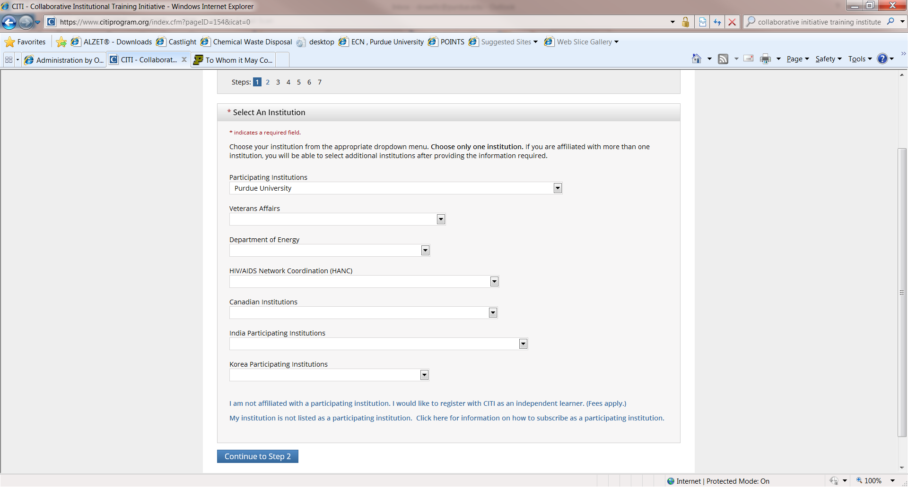

Under Participating institutions, select Purdue University from the drop down arrow.

Click on “Continue to Step 2”

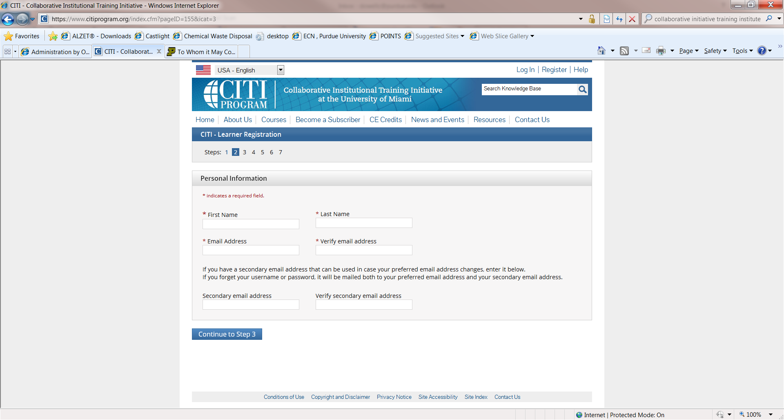

Enter your personal information

Select “continue to Step 3”

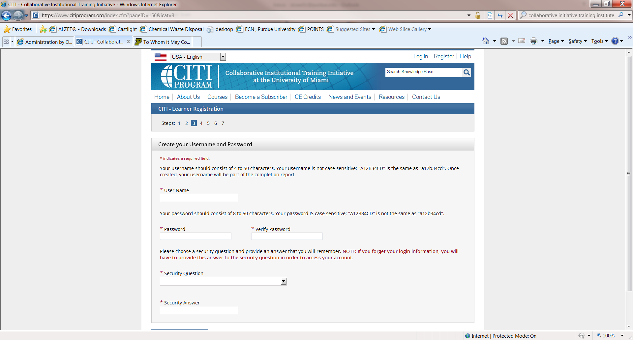

Enter a user name, password and security question/answer.

“Select continue to Step 4”

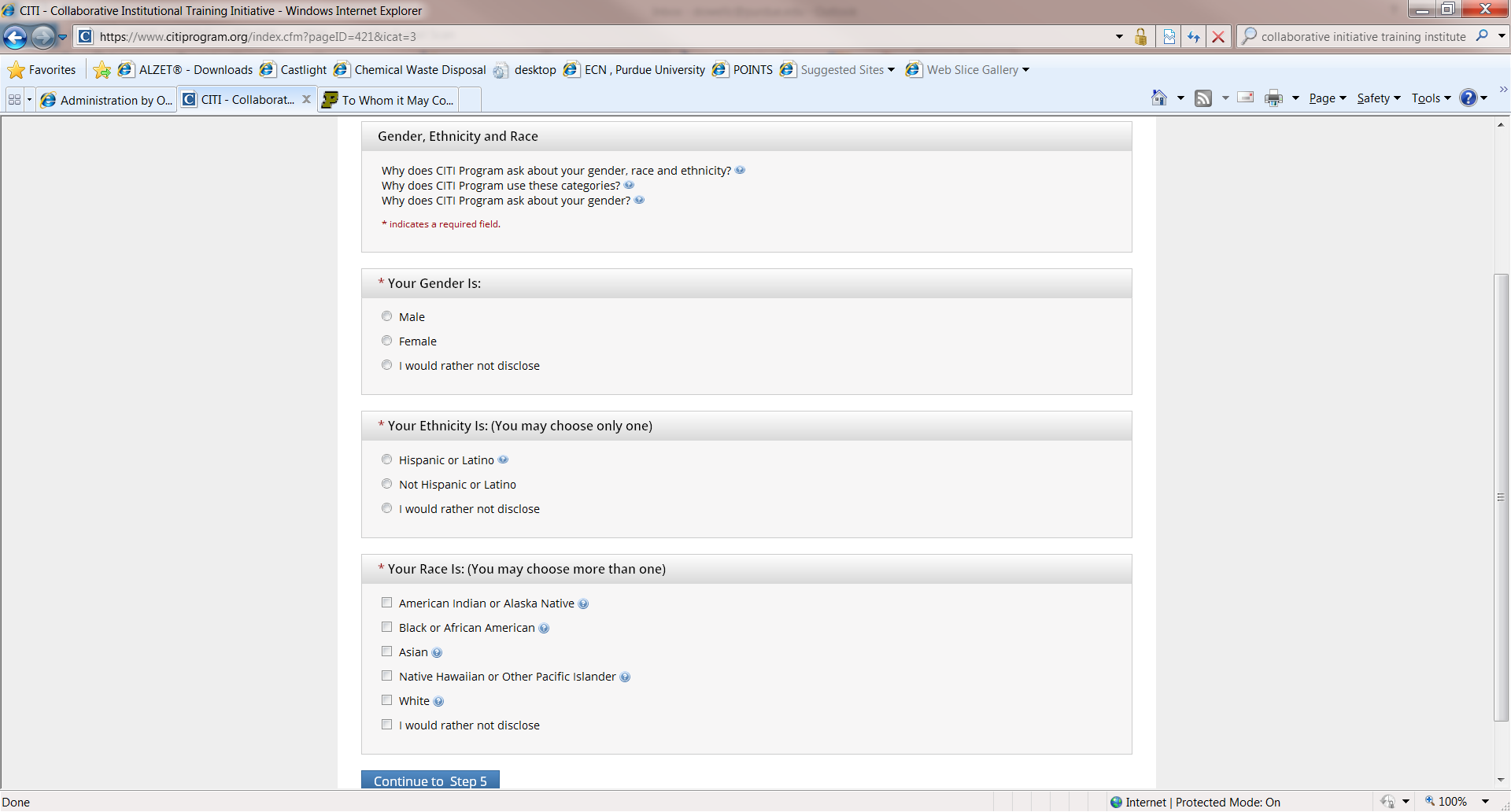

Complete your personal information and select “continue to Step 5”

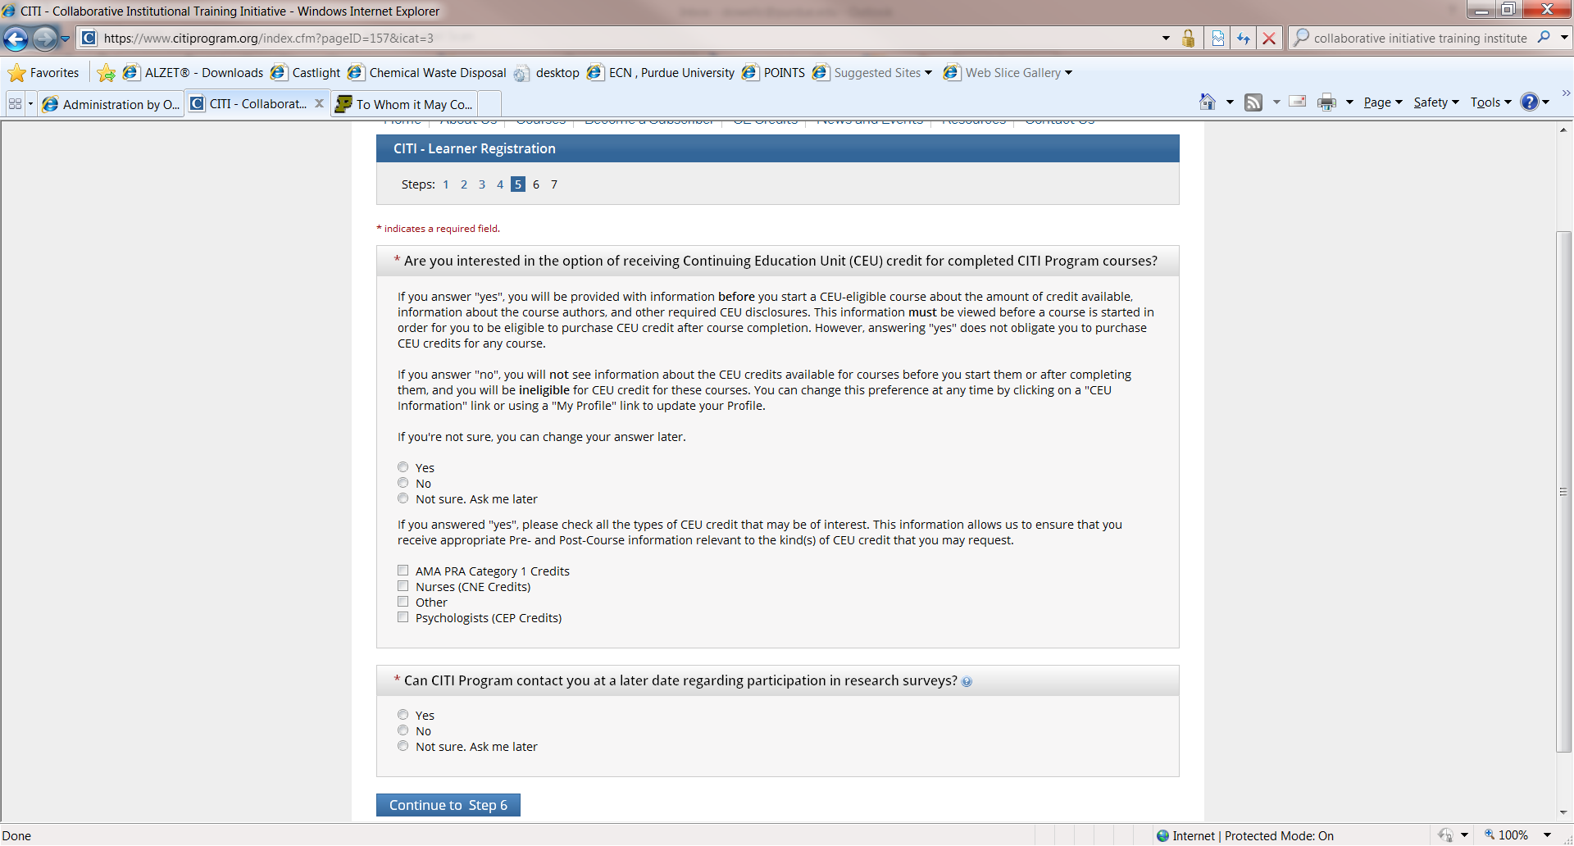

Complete and select

“Continue to Step 6”

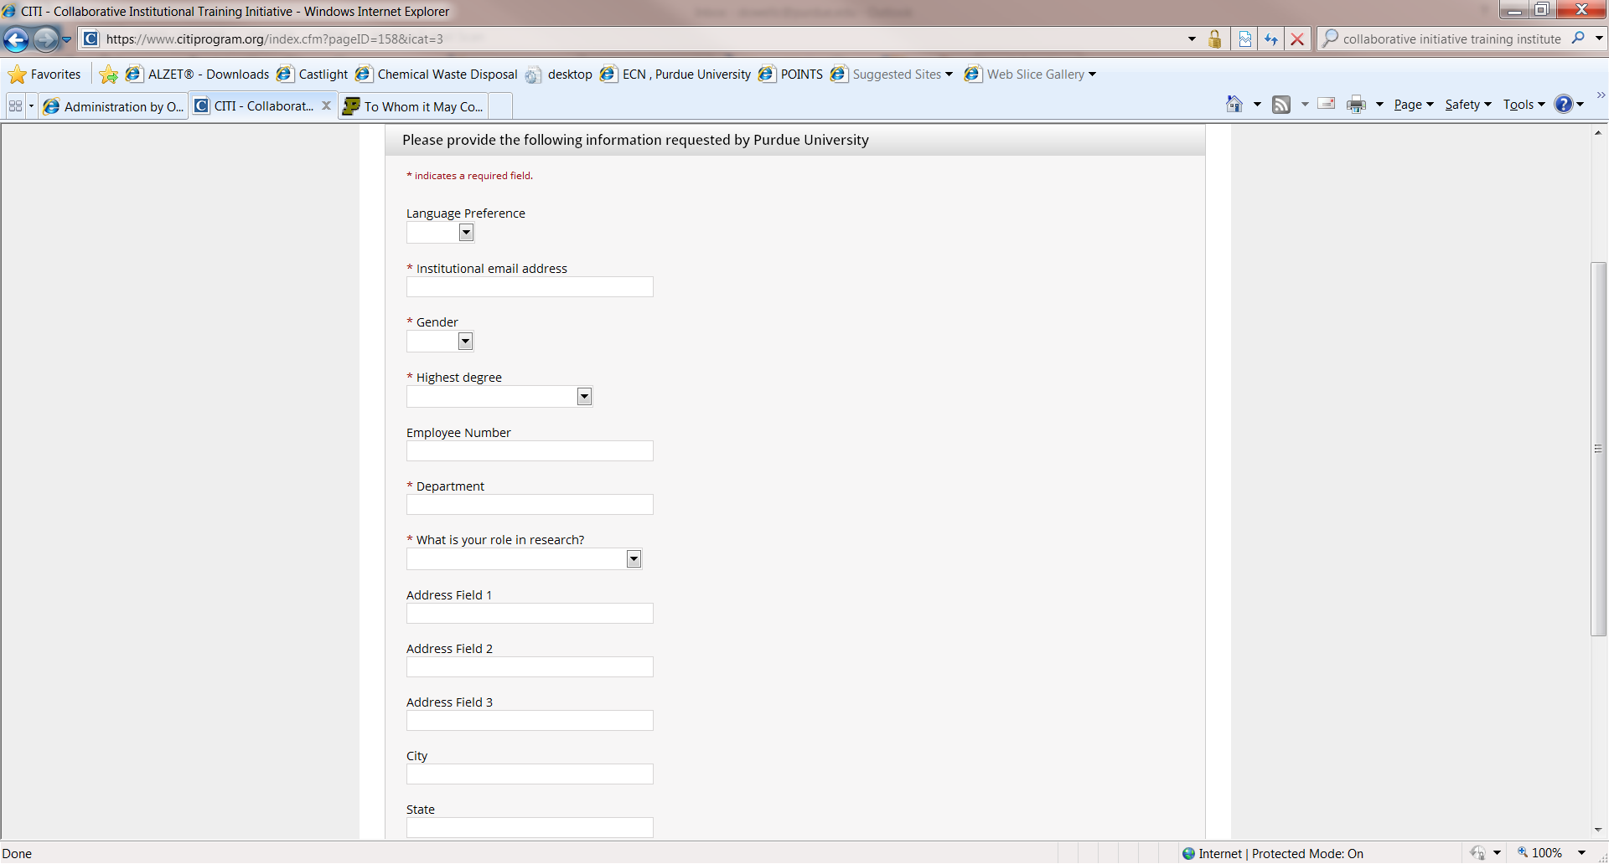

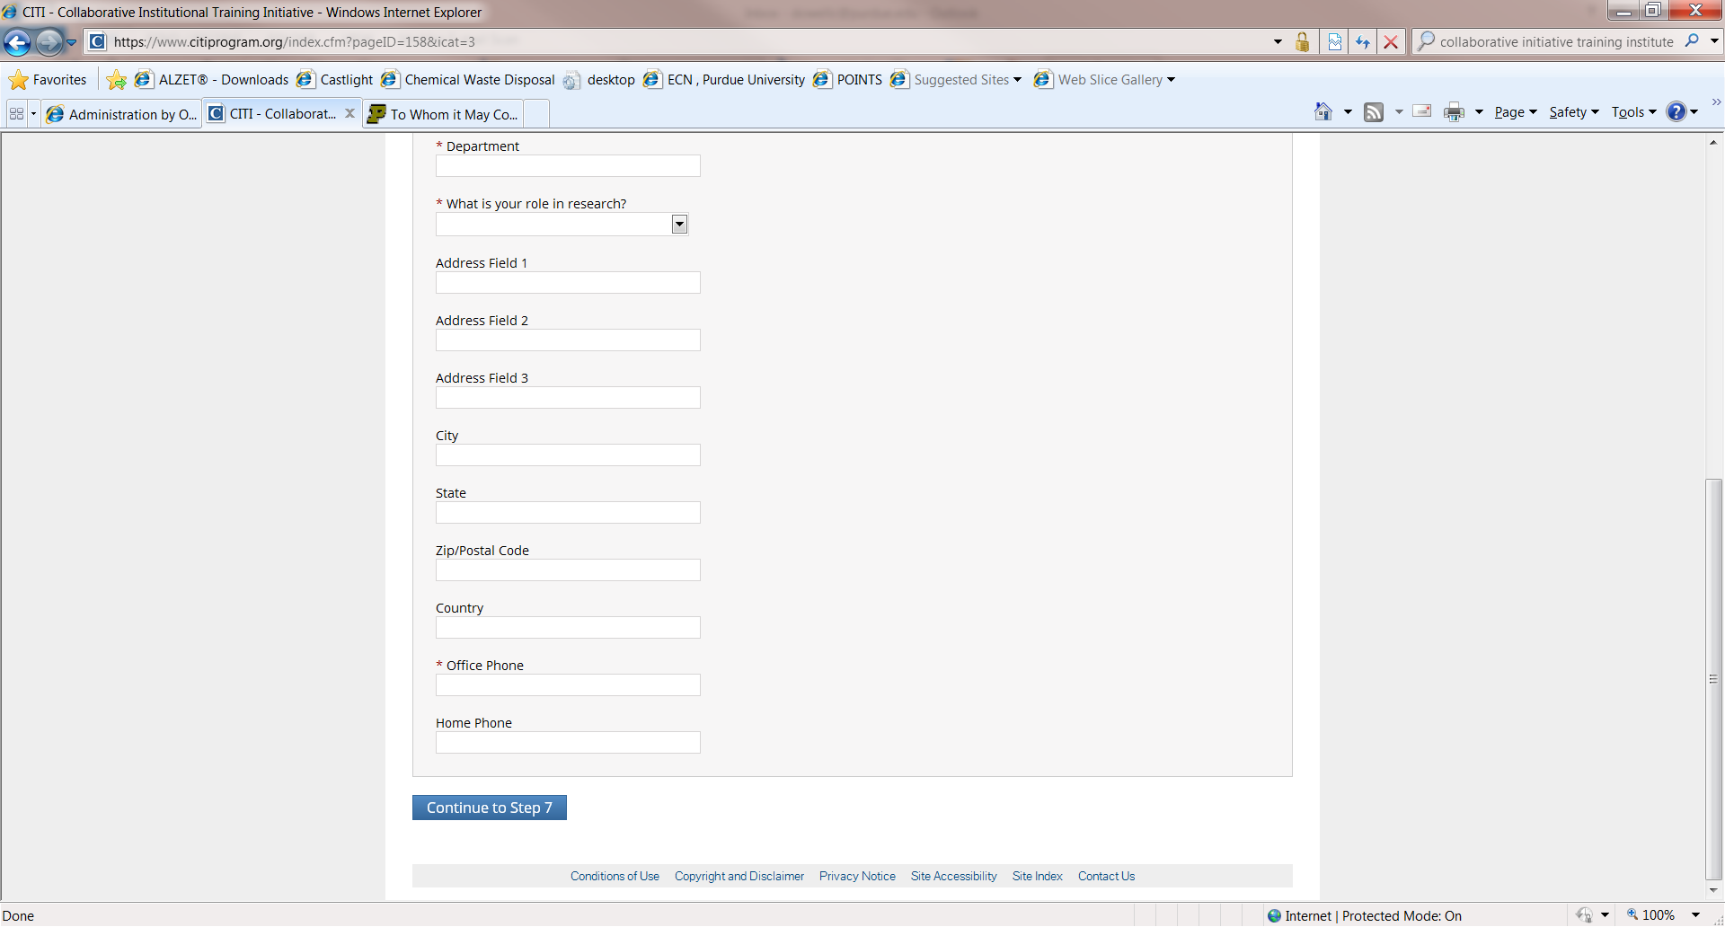

Complete required fields and select

“Continue to Step 7”

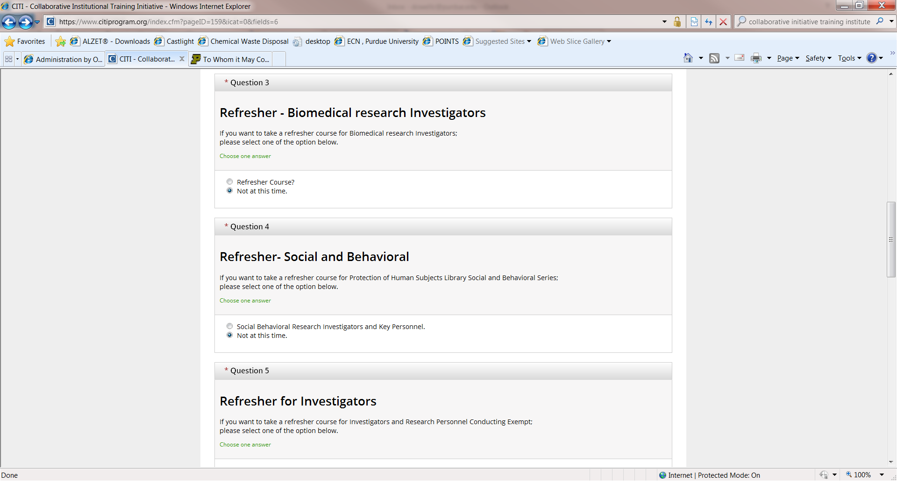

Questions 3, 4, 5, & 6

Select “Not at this time”

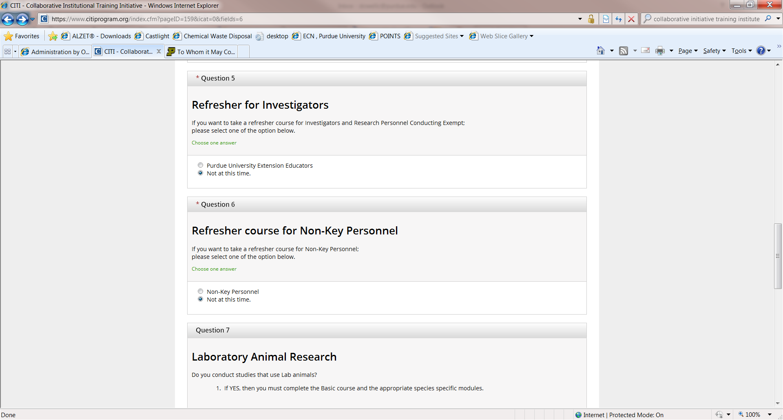

Questions 3, 4, 5, & 6

Select “Not at this time”

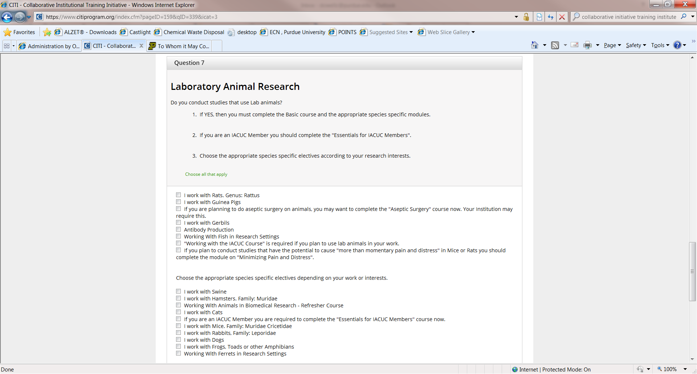

Please read Question 7 carefully!

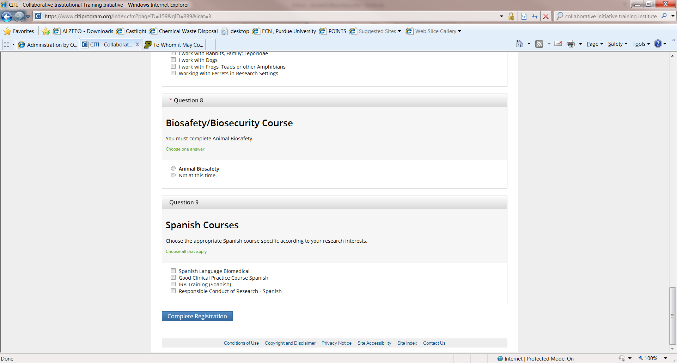

You must select “Animal Biosafety”!

Select “Complete Registration”

